MINI PROJECT

1.STUDENT MANAGEMENT SYSTEM:
  - 1. Project Title:
Student Management System Using Object-Oriented Programming in Python.
  - 2. Aim:
To develop a Student Management System using Object-Oriented Programming in Python that enables users to add, display, search, update, and delete student records, calculate average marks, and save student records using file handling.
  - 3. Brief Description:
The Student Management System is a console-based Python application developed using Object-Oriented Programming concepts. It helps educational institutions manage student information efficiently. The system allows users to add student details, display all records, search for a student using Student ID, update student information, delete student records, calculate average marks, and save all records into a text file.The project demonstrates the implementation of Abstraction, Encapsulation, Inheritance, Polymorphism, File Handling, and Exception Handling.
  - 4. Algorithm:
1. Start the program.
2. Display the main menu.
3. Add a new student.
4. Display all student records.
5. Search for a student.
6. Update student details.
7. Delete a student record.
8. Calculate average marks.
9. Save records to a text file.
10. Exit the program.
  - 5. Source Code:
from abc import ABC, abstractmethod
class StudentItem(ABC):
@abstractmethod
def display(self):
pass
class Student(StudentItem):
def __init__(self, student_id, student_name, marks):
self.__student_id = student_id
self.__student_name = student_name
self.__marks = marks
def get_student_id(self):
return self.__student_id
def get_student_name(self):
return self.__student_name
def get_marks(self):
return self.__marks
def set_student_name(self, student_name):
self.__student_name = student_name
def set_marks(self, marks):
self.__marks = marks
def display(self):
print("Student ID :", self.__student_id)
print("Student Name :", self.__student_name)
print("Marks :", self.__marks)
class StudentManagement(Student):
students = []
def __init__(self):
pass
def add_student(self):
try:
student_id = input("Enter Student ID : ")
student_name = input("Enter Student Name : ")
marks = float(input("Enter Marks : "))
s = Student(student_id, student_name, marks)
StudentManagement.students.append(s)
print("Student Added Successfully!")
except Exception:
print("Error While Adding Student!")
def search_student(self):
if len(StudentManagement.students) == 0:
print("No Student Records Available.")
else:
student_id = input("Enter Student ID to Search : ")
found = False
for s in StudentManagement.students:
if s.get_student_id() == student_id:
print("\nStudent Found!")
s.display()
found = True
break
if not found:
print("Student Record Not Found!")
def update_student(self):
if len(StudentManagement.students) == 0:
print("No Student Records Available.")
else:
student_id = input("Enter Student ID to Update : ")
found = False
for s in StudentManagement.students:
if s.get_student_id() == student_id:
name = input("Enter New Student Name : ")
marks = float(input("Enter New Marks : "))
s.set_student_name(name)
s.set_marks(marks)

print("Student Record Updated Successfully!")
found = True
break
if not found:
print("Student Record Not Found!")
def delete_student(self):
if len(StudentManagement.students) == 0:
print("No Student Records Available.")
else:
student_id = input("Enter Student ID to Delete : ")
found = False
for s in StudentManagement.students:
if s.get_student_id() == student_id:
StudentManagement.students.remove(s)
print("Student Record Deleted Successfully!")
found = True
break
if not found:
print("Student Record Not Found!")
def calculate_average(self):
if len(StudentManagement.students) == 0:
for s in StudentManagement.students:
total += s.get_marks()
average = total / len(StudentManagement.students)
print("Average Marks :", average)
def save_records(self):
file = open("student_records.txt", "w")
for s in StudentManagement.students:
file.write(s.get_student_id() + ",")
file.write(s.get_student_name() + ",")
file.write(str(s.get_marks()))
file.write("\n")
file.close()
print("Student Records Saved Successfully!")
obj = StudentManagement()
while True:
print("\n STUDENT MANAGEMENT SYSTEM ")
print("1. Add Student")
print("2. Display Students")
print("3. Search Student")
print("4. Update Student")
print("5. Delete Student")
print("6. Calculate Average Marks")
print("7. Save Records")
print("8. Exit")
try:
choice = int(input("Enter Your Choice : "))
if choice == 1:
obj.add_student()
elif choice == 2:
obj.display_students()
elif choice == 3:
obj.search_student()
elif choice == 4:
obj.update_student()
elif choice == 5:
obj.delete_student()
elif choice == 6:
obj.calculate_average()
elif choice == 7:
obj.save_records()
elif choice == 8:
print("Thank You!")
break

else:

print("Invalid Choice!")

except ValueError:

print("Please Enter a Valid Number!")
  - 6.SCREENSHOT OF OUTPUT:
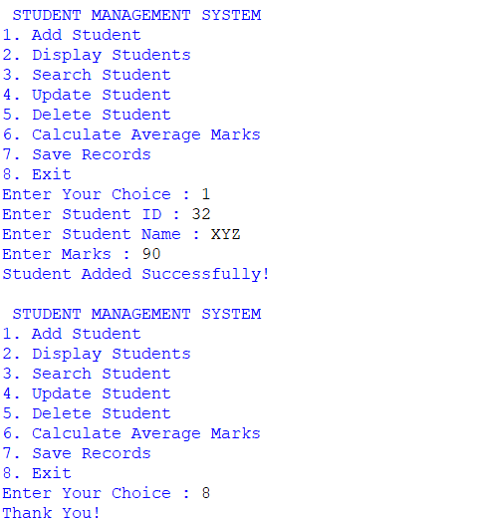
  - 7.CONCLUSION:
The Student Management System was successfully developed using Python and Object-Oriented Programming concepts. The system enables users to add, display, search, update, and delete student records, calculate average marks, and save records using file handling. It demonstrates the implementation of abstraction, encapsulation, inheritance, polymorphism, exception handling, and file handling, making it an effective mini project for learning OOP concepts in Python.

2. LIBRARY MANAGEMENT SYSTEM:
  - 1. Project Title:
Library Management System Using Object-Oriented Programming in Python.
  - 2. AIM:
To develop a Library Management System using Object-Oriented Programming (OOP) in Python that enables users to add books, search books, issue books, return books, display available books, and save library records using file handling.
  - 3. Brief Description:
The Library Management System is a console-based Python application developed using Object-Oriented Programming concepts. It helps libraries manage book records efficiently. The system allows users to add new books, search books by Book ID, issue books, return books, display all available books, and save library records into a text file.The project demonstrates the implementation of Abstraction, Encapsulation, Inheritance, Polymorphism, File Handling, and Exception Handling.
  - 4.ALGORITHM:
1.Start the program.
2.Display the main menu.
3.Add a new book.
4. Display available books.
5. Search for a book.
6.Issue a book.
7.Return a book.
8.Save records to a text file.
9.Exit the program.
  - 5.SOURCE CODE:
from abc import ABC, abstractmethod

class LibraryItem(ABC):

@abstractmethod
def display(self):
pass
class Book(LibraryItem):

def __init__(self, book_id, book_name, status):
self.__book_id = book_id
self.__book_name = book_name
self.__status = status

def get_book_id(self):
return self.__book_id

def get_book_name(self):
return self.__book_name

def get_status(self):
return self.__status

def set_status(self, status):
self.__status = status

def display(self):
print("Book ID :", self.__book_id)
print("Book Name :", self.__book_name)
print("Status :", self.__status)

class LibraryManagement(Book):

books = []

def __init__(self):
pass

def add_book(self):
try:
book_id = input("Enter Book ID : ")
book_name = input("Enter Book Name : ")

b = Book(book_id, book_name, "Available")
LibraryManagement.books.append(b)

print("Book Added Successfully!")

except Exception:
print("Error While Adding Book!")

def display_books(self):
if len(LibraryManagement.books) == 0:
print("No Books Available.")

else:
for b in LibraryManagement.books:
print("---------------------------")
b.display()

def search_book(self):
if len(LibraryManagement.books) == 0:
print("No Books Available.")

else:
book_id = input("Enter Book ID to Search : ")

found = False

for b in LibraryManagement.books:
if b.get_book_id() == book_id:
print("\nBook Found!")
b.display()
found = True
break

if not found:
print("Book Not Found!")

def issue_book(self):
if len(LibraryManagement.books) == 0:
print("No Books Available.")

else:
book_id = input("Enter Book ID to Issue : ")

found = False

for b in LibraryManagement.books:
if b.get_book_id() == book_id:
b.set_status("Issued")
print("Book Issued Successfully!")
found = True
break

if not found:
print("Book Not Found!")

def return_book(self):
if len(LibraryManagement.books) == 0:
print("No Books Available.")

else:
book_id = input("Enter Book ID to Return : ")

found = False

for b in LibraryManagement.books:
if b.get_book_id() == book_id:
b.set_status("Available")
print("Book Returned Successfully!")
found = True
break

if not found:
print("Book Not Found!")

def save_records(self):
file = open("library_records.txt", "w")

for b in LibraryManagement.books:
file.write(b.get_book_id() + ",")
file.write(b.get_book_name() + ",")
file.write(b.get_status())
file.write("\n")

file.close()
print("Library Records Saved Successfully!")

obj = LibraryManagement()

while True:

print("\n LIBRARY MANAGEMENT SYSTEM ")
print("1. Add Book")
print("2. Display Books")
print("3. Search Book")
print("4. Issue Book")
print("5. Return Book")
print("6. Save Records")
print("7. Exit")

try:
choice = int(input("Enter Your Choice : "))

if choice == 1:
obj.add_book()

elif choice == 2:
obj.display_books()

elif choice == 3:
obj.search_book()

elif choice == 4:
obj.issue_book()

elif choice == 5:
obj.return_book()

elif choice == 6:
obj.save_records()

elif choice == 7:
print("Thank You!")
break

else:
print("Invalid Choice!")

except ValueError:
print("Please Enter a Valid Number!")
  - 6.SCREENSHOT OF OUTPUT:
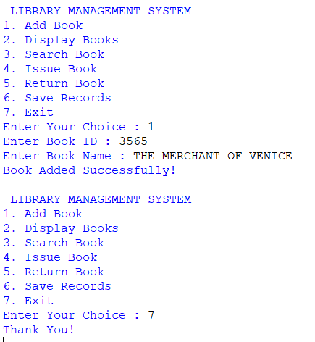
  - 7.CONCLUSION:
The Library Management System was successfully developed using Python and Object-Oriented Programming (OOP) concepts. The system enables users to add books, search for books, issue and return books, display available books, and save library records using file handling. The project demonstrates the implementation of abstraction, encapsulation, inheritance, polymorphism, exception handling, and file handling, making it an effective mini project for learning OOP concepts in Python.

3. BANK ACCOUNT MANAGEMENT SYSTEM:
  - 1. Project Title:
Bank Account Management System Using Object-Oriented Programming in Python.
  - 2.AIM:
To develop a Bank Account Management System using Object-Oriented Programming (OOP) in Python that enables users to create bank accounts, deposit money, withdraw money, check account balance, and save account records using file handling.
  - 3.DESCRIPTION:
The Bank Account Management System is a console-based Python application developed using Object-Oriented Programming concepts. It helps banks manage customer account details efficiently. The system allows users to create new bank accounts, deposit and withdraw money, check account balances, display account details, and save account records into a text file.The project demonstrates the implementation of Abstraction, Encapsulation, Inheritance, Polymorphism, File Handling, and Exception Handling.
  - 4.ALGORITHM:
1. Start the program.
2.Display the main menu.
3.Create a new bank account.
4.Display account details.
5.Deposit money.
6.Withdraw money.
7. Check account balance.
8.Save account records to a text file.
9.Exit the program.
  - 5.SOURCE CODE:
from abc import ABC, abstractmethod
class BankItem(ABC):

@abstractmethod
def display(self):
pass
class Account(BankItem):
def __init__(self, account_no, customer_name, balance):
self.__account_no = account_no
self.__customer_name = customer_name
self.__balance = balance
def get_account_no(self):
return self.__account_no

def get_customer_name(self):
return self.__customer_name

def get_balance(self):
return self.__balance

def set_balance(self, balance):
self.__balance = balance

def display(self):
print("Account Number :", self.__account_no)
print("Customer Name :", self.__customer_name)
print("Balance :", self.__balance)

class BankManagement(Account):

accounts = []

def __init__(self):
pass

def create_account(self):

try:
account_no = input("Enter Account Number : ")
customer_name = input("Enter Customer Name : ")
balance = float(input("Enter Initial Balance : "))

a = Account(account_no, customer_name, balance)

BankManagement.accounts.append(a)

print("Account Created Successfully!")

except Exception:
print("Error While Creating Account!")

def display_accounts(self):

if len(BankManagement.accounts) == 0:
print("No Account Records Available.")

else:
for a in BankManagement.accounts:
print("---------------------------")
a.display()

def deposit_money(self):

if len(BankManagement.accounts) == 0:
print("No Account Records Available.")

else:
account_no = input("Enter Account Number : ")

found = False

for a in BankManagement.accounts:

if a.get_account_no() == account_no:

amount = float(input("Enter Deposit Amount : "))

new_balance = a.get_balance() + amount

a.set_balance(new_balance)

print("Amount Deposited Successfully!")

found = True
break

if not found:
print("Account Not Found!")

def withdraw_money(self):

if len(BankManagement.accounts) == 0:
print("No Account Records Available.")

else:
account_no = input("Enter Account Number : ")

found = False

for a in BankManagement.accounts:

if a.get_account_no() == account_no:

amount = float(input("Enter Withdrawal Amount : "))

if amount <= a.get_balance():

new_balance = a.get_balance() - amount

a.set_balance(new_balance)

print("Amount Withdrawn Successfully!")

else:
print("Insufficient Balance!")

found = True
break

if not found:
print("Account Not Found!")

def check_balance(self):

if len(BankManagement.accounts) == 0:
print("No Account Records Available.")

else:
account_no = input("Enter Account Number : ")

found = False

for a in BankManagement.accounts:

if a.get_account_no() == account_no:

print("Current Balance :", a.get_balance())

found = True
break

if not found:
print("Account Not Found!")

def save_records(self):

file = open("bank_records.txt", "w")

for a in BankManagement.accounts:

file.write(a.get_account_no() + ",")
file.write(a.get_customer_name() + ",")
file.write(str(a.get_balance()))
file.write("\n")

file.close()

print("Bank Records Saved Successfully!")

obj = BankManagement()

while True:

print("\n BANK ACCOUNT MANAGEMENT SYSTEM ")
print("1. Create Account")
print("2. Display Accounts")
print("3. Deposit Money")
print("4. Withdraw Money")
print("5. Check Balance")
print("6. Save Records")
print("7. Exit")

try:

choice = int(input("Enter Your Choice : "))

if choice == 1:
obj.create_account()

elif choice == 2:
obj.display_accounts()

elif choice == 3:
obj.deposit_money()

elif choice == 4:
obj.withdraw_money()

elif choice == 5:
obj.check_balance()

elif choice == 6:
obj.save_records()

elif choice == 7:
print("Thank You!")
break

else:
print("Invalid Choice!")

except ValueError:
print("Please Enter a Valid Number!")
  - 6.SCREENSHOT OF OUTPUT:

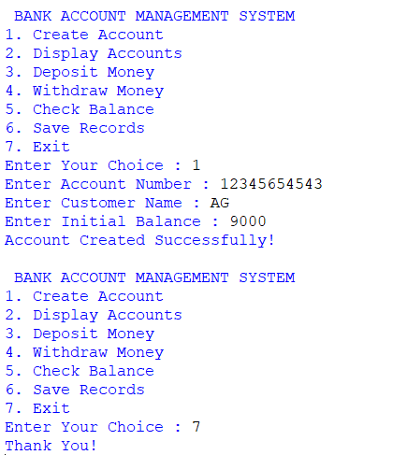
  - 7.CONCLUSION:
The Bank Account Management System was successfully developed using Python and Object-Oriented Programming (OOP) concepts. The system enables users to create bank accounts, deposit and withdraw money, check account balances, display account information, and save account records using file handling. This project demonstrates the implementation of abstraction, encapsulation, inheritance, polymorphism, exception handling, and file handling, making it an effective mini project for learning OOP concepts in Python.

4. EMPLOYEE PAYROLL SYSTEM:
  - 1.PROJECT TITLE:
Employee Payroll System Using Object-Oriented Programming in Python.
  - 2.AIM:
To develop an Employee Payroll System using Object-Oriented Programming (OOP) in Python that enables users to add employee details, calculate salaries, display employee records, search employees, and save payroll records using file handling.
  - 3.DESCRIPTION:
The Employee Payroll System is a console-based Python application developed using Object-Oriented Programming concepts. It helps organizations manage employee payroll records efficiently. The system allows users to add employee details, display employee information, search employees using Employee ID, calculate net salary based on basic salary and bonus, and save payroll records into a text file.
The project demonstrates the implementation of Abstraction, Encapsulation, Inheritance, Polymorphism, File Handling, and Exception Handling.
  - 4.ALGORITHM:
1. Start the program.
2.Display the main menu.
3.Add a new employee.
4.Display all employee records.
5.Search for an employee.
6.Calculate employee salary.
7.Save payroll records to a text file.
8.Exit the program.
  - 5.SOURCE CODE:
from abc import ABC, abstractmethod

# Abstract Class
class EmployeeItem(ABC):

@abstractmethod
def display(self):
pass

# Base Class
class Employee(EmployeeItem):

def __init__(self, emp_id, emp_name, basic_salary):

self.__emp_id = emp_id
self.__emp_name = emp_name
self.__basic_salary = basic_salary

def get_emp_id(self):
return self.__emp_id

def get_emp_name(self):
return self.__emp_name

def get_basic_salary(self):
return self.__basic_salary

def display(self):

print("Employee ID :", self.__emp_id)
print("Employee Name :", self.__emp_name)
print("Basic Salary :", self.__basic_salary)

# Derived Class
class PayrollManagement(Employee):

employees = []

def __init__(self):

self.net_salary = 0

def add_employee(self):

try:

emp_id = input("Enter Employee ID : ")
emp_name = input("Enter Employee Name : ")
basic_salary = float(input("Enter Basic Salary : "))

e = Employee(emp_id, emp_name, basic_salary)

PayrollManagement.employees.append(e)

print("Employee Added Successfully!")

except Exception:

print("Error While Adding Employee!")

def display_employees(self):

if len(PayrollManagement.employees) == 0:

print("No Employee Records Available.")

else:

for e in PayrollManagement.employees:

print("---------------------------")
e.display()

def search_employee(self):

if len(PayrollManagement.employees) == 0:

print("No Employee Records Available.")

else:

emp_id = input("Enter Employee ID to Search : ")

found = False

for e in PayrollManagement.employees:

if e.get_emp_id() == emp_id:

print("\nEmployee Found!")
e.display()

found = True
break

if not found:

print("Employee Record Not Found!")

def calculate_salary(self):

if len(PayrollManagement.employees) == 0:

print("No Employee Records Available.")

else:

emp_id = input("Enter Employee ID : ")

found = False

for e in PayrollManagement.employees:

if e.get_emp_id() == emp_id:

bonus = float(input("Enter Bonus Amount : "))

self.net_salary = e.get_basic_salary() + bonus

print("Net Salary :", self.net_salary)

found = True
break

if not found:

print("Employee Record Not Found!")

def save_records(self):

file = open("payroll_records.txt", "w")

for e in PayrollManagement.employees:

file.write(e.get_emp_id() + ",")
file.write(e.get_emp_name() + ",")
file.write(str(e.get_basic_salary()))
file.write("\n")

file.close()

print("Payroll Records Saved Successfully!")

obj = PayrollManagement()

while True:

print("\n EMPLOYEE PAYROLL SYSTEM ")
print("1. Add Employee")
print("2. Display Employees")
print("3. Search Employee")
print("4. Calculate Salary")
print("5. Save Records")
print("6. Exit")

try:

choice = int(input("Enter Your Choice : "))

if choice == 1:

obj.add_employee()

elif choice == 2:

obj.display_employees()

elif choice == 3:

obj.search_employee()

elif choice == 4:

obj.calculate_salary()

elif choice == 5:

obj.save_records()

elif choice == 6:

print("Thank You!")
break

else:

print("Invalid Choice!")

except ValueError:

print("Please Enter a Valid Number!")
  - 6.SCREENSHOT OF OUTPUT:
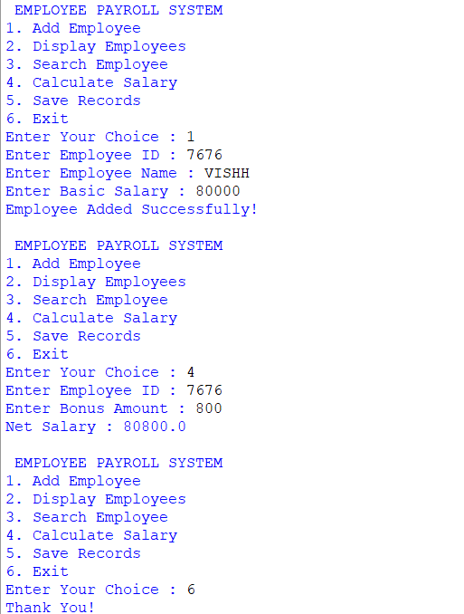
  - 7.CONCLUSION:
The Employee Payroll System was successfully developed using Python and Object-Oriented Programming (OOP) concepts. The system enables users to add employee records, search employee details, calculate employee salaries, display employee information, and save payroll records using file handling. The project demonstrates the implementation of abstraction, encapsulation, inheritance, polymorphism, exception handling, and file handling, making it an effective mini project for learning OOP concepts in Python.

5. INVENTORY MANAGEMENT SYSTEM:
  - 1.PROJECT TITLE:
Inventory Management System Using Object-Oriented Programming in Python.
  - 2.AIM:
To develop an Inventory Management System using Object-Oriented Programming (OOP) in Python that enables users to add products, display inventory, search products, update product quantity, and save inventory records using file handling.
  - 3.DESCRIPTION:
The Inventory Management System is a console-based Python application developed using Object-Oriented Programming concepts. It helps shops and businesses maintain product inventory efficiently. The system allows users to add new products, display all inventory records, search for products using Product ID, update product quantities, and save inventory records into a text file.The project demonstrates the implementation of Abstraction, Encapsulation, Inheritance, Polymorphism, File Handling, and Exception Handling.
  - 4.ALGORITHM:
1. Start the program.
2.Display the main menu.
3.Add a new product.
4.Display all products.
5.Search for a product.
6.Update product quantity.
7.Save inventory records to a text file.
8.Exit the program
  - 5.SOURCE CODE:
from abc import ABC, abstractmethod
class InventoryItem(ABC):

@abstractmethod
def display(self):
pass

class Product(InventoryItem):

def __init__(self, product_id, product_name, quantity):

self.__product_id = product_id
self.__product_name = product_name
self.__quantity = quantity

def get_product_id(self):
return self.__product_id

def get_product_name(self):
return self.__product_name

def get_quantity(self):
return self.__quantity

def set_quantity(self, quantity):
self.__quantity = quantity

def display(self):

print("Product ID :", self.__product_id)
print("Product Name :", self.__product_name)
print("Quantity :", self.__quantity)
class InventoryManagement(Product):

products = []

def __init__(self):

pass

def add_product(self):

try:

product_id = input("Enter Product ID : ")
product_name = input("Enter Product Name : ")
quantity = int(input("Enter Quantity : "))

p = Product(product_id, product_name, quantity)

InventoryManagement.products.append(p)

print("Product Added Successfully!")

except Exception:

print("Error While Adding Product!")

def display_products(self):

if len(InventoryManagement.products) == 0:

print("No Product Records Available.")

else:

for p in InventoryManagement.products:

print("---------------------------")
p.display()

def search_product(self):

if len(InventoryManagement.products) == 0:

print("No Product Records Available.")

else:

product_id = input("Enter Product ID to Search : ")

found = False

for p in InventoryManagement.products:

if p.get_product_id() == product_id:

print("\nProduct Found!")
p.display()

found = True
break

if not found:

print("Product Record Not Found!")

def update_quantity(self):

if len(InventoryManagement.products) == 0:

print("No Product Records Available.")

else:

product_id = input("Enter Product ID to Update : ")

found = False

for p in InventoryManagement.products:

if p.get_product_id() == product_id:

quantity = int(input("Enter New Quantity : "))

p.set_quantity(quantity)

print("Product Quantity Updated Successfully!")

found = True
break

if not found:

print("Product Record Not Found!")

def save_records(self):

file = open("inventory_records.txt", "w")

for p in InventoryManagement.products:

file.write(p.get_product_id() + ",")
file.write(p.get_product_name() + ",")
file.write(str(p.get_quantity()))
file.write("\n")

file.close()

print("Inventory Records Saved Successfully!")

obj = InventoryManagement()

while True:

print("\n INVENTORY MANAGEMENT SYSTEM ")
print("1. Add Product")
print("2. Display Products")
print("3. Search Product")
print("4. Update Product Quantity")
print("5. Save Records")
print("6. Exit")

try:

choice = int(input("Enter Your Choice : "))

if choice == 1:

obj.add_product()

elif choice == 2:

obj.display_products()

elif choice == 3:

obj.search_product()

elif choice == 4:

obj.update_quantity()

elif choice == 5:

obj.save_records()

elif choice == 6:

print("Thank You!")
break

else:

print("Invalid Choice!")

except ValueError:

print("Please Enter a Valid Number!")
  - 6.SCREENSHOT OF OUTPUT:
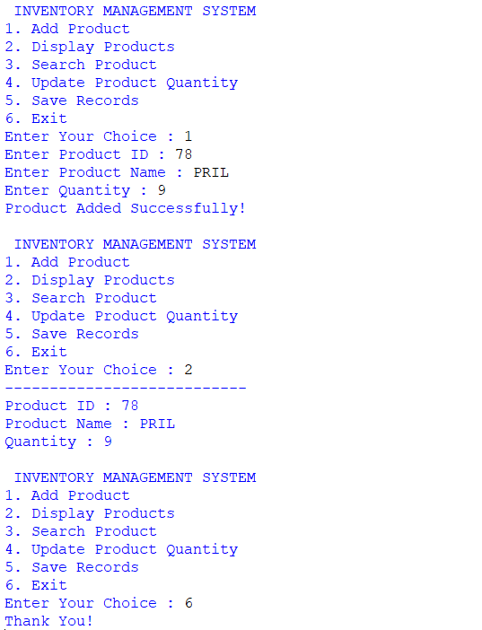
  - 7.CONCLUSION:
The Inventory Management System was successfully developed using Python and Object-Oriented Programming (OOP) concepts. The system enables users to add products, display inventory records, search products, update product quantities, and save inventory records using file handling. It demonstrates the implementation of abstraction, encapsulation, inheritance, polymorphism, exception handling, and file handling, making it an effective mini project for learning OOP concepts in Python.

6. QUIZ MANAGEMENT SYSTEM:
  - 1.PROJECT TITLE:
Quiz Management System Using Object-Oriented Programming in Python.
  - 2.AIM:
To develop a Quiz Management System using Object-Oriented Programming (OOP) in Python that allows users to add quiz questions, conduct quizzes, calculate scores, display results, and save quiz records using file handling.
  - 3.DESCRIPTION:
The Quiz Management System is a console-based Python application developed using Object-Oriented Programming concepts. It helps users create and manage quizzes efficiently. The system allows users to add quiz questions, display all questions, conduct quizzes by accepting user answers, calculate and display scores, and save quiz records into a text file.The project demonstrates the implementation of Abstraction, Encapsulation, Inheritance, Polymorphism, File Handling, and Exception Handling.
  - 4.ALGORITHM:
1. Start the program.
2.Display the main menu.
3.Add quiz questions.
4.Display all quiz questions.
5.Conduct the quiz.
6.Calculate and display the score.
7.Save quiz records to a text file.
8.Exit the program.
  - 5.SOURCE CODE:
from abc import ABC, abstractmethod
class QuizItem(ABC):

@abstractmethod
def display(self):
pass
class Question(QuizItem):

def __init__(self, question, answer):

self.__question = question
self.__answer = answer

def get_question(self):
return self.__question

def get_answer(self):
return self.__answer

def display(self):

print("Question :", self.__question)
print("Answer :", self.__answer)
class QuizManagement(Question):

questions = []

def __init__(self):

self.score = 0

def add_question(self):

try:

question = input("Enter Question : ")
answer = input("Enter Correct Answer : ")

q = Question(question, answer)

QuizManagement.questions.append(q)

print("Question Added Successfully!")

except Exception:

print("Error While Adding Question!")

def display_questions(self):

if len(QuizManagement.questions) == 0:

print("No Questions Available.")

else:

for q in QuizManagement.questions:

print("---------------------------")
q.display()

def conduct_quiz(self):

if len(QuizManagement.questions) == 0:

print("No Questions Available.")

else:

self.score = 0

for q in QuizManagement.questions:

print("\n", q.get_question())

user_answer = input("Enter Your Answer : ")

if user_answer.lower() == q.get_answer().lower():

print("Correct Answer!")

self.score += 1

else:

print("Wrong Answer!")
print("Correct Answer :", q.get_answer())

def display_score(self):

print("\nYour Score :", self.score, "/", len(QuizManagement.questions))

def save_records(self):

file = open("quiz_records.txt", "w")

for q in QuizManagement.questions:

file.write(q.get_question() + ",")
file.write(q.get_answer())
file.write("\n")

file.close()

print("Quiz Records Saved Successfully!")

obj = QuizManagement()

while True:

print("\n QUIZ MANAGEMENT SYSTEM ")
print("1. Add Question")
print("2. Display Questions")
print("3. Conduct Quiz")
print("4. Display Score")
print("5. Save Records")
print("6. Exit")

try:

choice = int(input("Enter Your Choice : "))

if choice == 1:

obj.add_question()

elif choice == 2:

obj.display_questions()

elif choice == 3:

obj.conduct_quiz()

elif choice == 4:

obj.display_score()

elif choice == 5:

obj.save_records()

elif choice == 6:

print("Thank You!")
break

else:

print("Invalid Choice!")

except ValueError:

print("Please Enter a Valid Number!")
  - 6.SCREENSHOT OF OUTPUT:
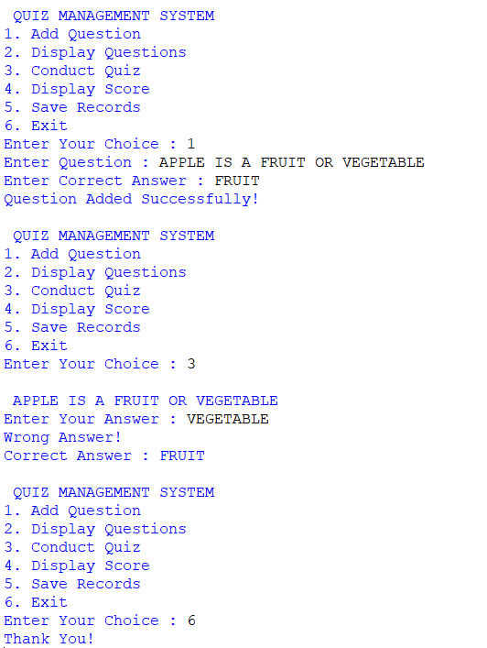
  - 7.CONCLUSION:
The Quiz Management System was successfully developed using Python and Object-Oriented Programming (OOP) concepts. The system enables users to add quiz questions, display questions, conduct quizzes, calculate scores, display results, and save quiz records using file handling. It demonstrates the implementation of abstraction, encapsulation, inheritance, polymorphism, exception handling, and file handling, making it an effective mini project for learning OOP concepts in Python.

7. HOSPITAL PATIENT RECORD SYSTEM:
  - 1.PROJECT TITLE:
Hospital Patient Record System Using Object-Oriented Programming in Python.
  - 2.AIM:
To develop a Hospital Patient Record System using Object-Oriented Programming (OOP) in Python that enables users to register patients, search patient records, update patient information, delete patient records, and save patient records using file handling.
  - 3.DESCRIPTION:
The Hospital Patient Record System is a console-based Python application developed using Object-Oriented Programming concepts. The system helps hospitals maintain patient information efficiently. It allows users to register new patients, search existing records, update patient details, delete patient records, display all patient records, and save records permanently in a text file.The project demonstrates the implementation of OOP concepts such as Abstraction, Encapsulation, Inheritance, Polymorphism, File Handling, and Exception Handling.
  - 4.ALGORITHM:
1. Start the program.
2.Display the main menu.
3.Register a new patient.
4.Display all patient records.
5.Search for a patient using Patient ID.
6.Update patient details.
7.Delete patient records.
8.Save all patient records to a text file.
9.Exit the program.
  - 5.SOURCE CODE:
from abc import ABC, abstractmethod
class HospitalItem(ABC):

@abstractmethod
def display(self):
pass
class Patient(HospitalItem):

def __init__(self, patient_id, name, age, disease):

self.__patient_id = patient_id
self.__name = name
self.__age = age
self.__disease = disease

def get_patient_id(self):
return self.__patient_id

def get_name(self):
return self.__name

def get_age(self):
return self.__age

def get_disease(self):
return self.__disease

def set_name(self, name):
self.__name = name

def set_age(self, age):
self.__age = age

def set_disease(self, disease):
self.__disease = disease

def display(self):

print("Patient ID :", self.__patient_id)
print("Name :", self.__name)
print("Age :", self.__age)
print("Disease :", self.__disease)
class HospitalManagement(Patient):

patients = []

def __init__(self):

pass

def register_patient(self):

try:

patient_id = input("Enter Patient ID : ")
name = input("Enter Patient Name : ")
age = input("Enter Patient Age : ")
disease = input("Enter Disease : ")

p = Patient(patient_id, name, age, disease)

HospitalManagement.patients.append(p)

print("Patient Registered Successfully!")

except Exception:

print("Error While Registering Patient!")

def display_patients(self):

if len(HospitalManagement.patients) == 0:

print("No Patient Records Available.")

else:

for p in HospitalManagement.patients:

print("---------------------------")
p.display()

def search_patient(self):

if len(HospitalManagement.patients) == 0:

print("No Patient Records Available.")

else:

patient_id = input("Enter Patient ID to Search : ")

found = False

for p in HospitalManagement.patients:

if p.get_patient_id() == patient_id:

print("\nPatient Found!")
p.display()

found = True
break

if not found:

print("Patient Record Not Found!")

def update_patient(self):

if len(HospitalManagement.patients) == 0:

print("No Patient Records Available.")

else:

patient_id = input("Enter Patient ID to Update : ")

found = False

for p in HospitalManagement.patients:

if p.get_patient_id() == patient_id:

name = input("Enter New Name : ")
age = input("Enter New Age : ")
disease = input("Enter New Disease : ")

p.set_name(name)
p.set_age(age)
p.set_disease(disease)

print("Patient Record Updated Successfully!")

found = True
break

if not found:

print("Patient Record Not Found!")

def delete_patient(self):

if len(HospitalManagement.patients) == 0:

print("No Patient Records Available.")

else:

patient_id = input("Enter Patient ID to Delete : ")

found = False

for p in HospitalManagement.patients:

if p.get_patient_id() == patient_id:

HospitalManagement.patients.remove(p)

print("Patient Record Deleted Successfully!")

found = True
break

if not found:

print("Patient Record Not Found!")

def save_records(self):

file = open("patient_records.txt", "w")

for p in HospitalManagement.patients:

file.write(p.get_patient_id() + ",")
file.write(p.get_name() + ",")
file.write(str(p.get_age()) + ",")
file.write(p.get_disease())
file.write("\n")

file.close()

print("Patient Records Saved Successfully!")

obj = HospitalManagement()

while True:

print("\n HOSPITAL PATIENT RECORD SYSTEM ")
print("1. Register Patient")
print("2. Display Patients")
print("3. Search Patient")
print("4. Update Patient")
print("5. Delete Patient")
print("6. Save Records")
print("7. Exit")

try:

choice = int(input("Enter Your Choice : "))

if choice == 1:

obj.register_patient()

elif choice == 2:

obj.display_patients()

elif choice == 3:

obj.search_patient()

elif choice == 4:

obj.update_patient()

elif choice == 5:

obj.delete_patient()

elif choice == 6:

obj.save_records()

elif choice == 7:

print("Thank You!")
break

else:

print("Invalid Choice!")

except ValueError:

print("Please Enter a Valid Number!")
  - 6.SCREENSHOT OF OUTPUT:
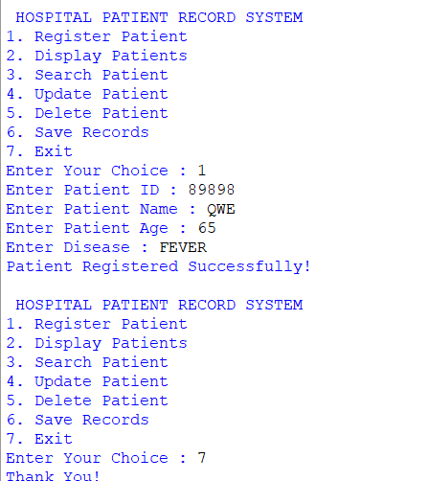
  - 7.CONCLUSION:
The Hospital Patient Record System was successfully developed using Python and Object-Oriented Programming (OOP) concepts. The system enables users to register patients, search, update, and delete patient records, display patient information, and save records using file handling. This project demonstrates the effective implementation of abstraction, encapsulation, inheritance, polymorphism, exception handling, and file handling, making it a suitable mini project for learning OOP concepts in Python.

8. VEHICLE RENTAL MANAGEMENT SYSTEM:
  - 1.PROJECT TITLE:
Vehicle Rental Management System Using Object-Oriented Programming in Python.
  - 2.AIM:
To develop a Vehicle Rental Management System using Object-Oriented Programming (OOP) in Python that enables users to add vehicles, rent vehicles, return vehicles, calculate rental charges, and save rental records using file handling.
  - 3.DESCRIPTION:
The Vehicle Rental Management System is a console-based Python application developed using Object-Oriented Programming concepts. It helps rental agencies manage vehicle information efficiently. The system allows users to add new vehicles, display available vehicles, rent vehicles, return rented vehicles, calculate rental charges based on the number of rental days, and save vehicle records into a text file.The project demonstrates the implementation of OOP concepts such as Abstraction, Encapsulation, Inheritance, Polymorphism, File Handling, and Exception Handling.
  - 4.ALGORITHM:
1. Start the program.
2.Display the main menu.
3.Add a new vehicle.
4.Display all available vehicles.
5.Rent a vehicle.
6. Return a rented vehicle.
7.Calculate rental charges.
8.Save vehicle records to a text file.
9.Exit the program.
  - 5.SOURCE CODE:
from abc import ABC, abstractmethod
class VehicleItem(ABC):

@abstractmethod
def display(self):
pass
class Vehicle(VehicleItem):

def __init__(self, vehicle_id, vehicle_name, rent_per_day):

self.__vehicle_id = vehicle_id
self.__vehicle_name = vehicle_name
self.__rent_per_day = rent_per_day

def get_vehicle_id(self):
return self.__vehicle_id

def get_vehicle_name(self):
return self.__vehicle_name

def get_rent_per_day(self):
return self.__rent_per_day

def display(self):

print("Vehicle ID :", self.__vehicle_id)
print("Vehicle Name :", self.__vehicle_name)
print("Rent Per Day :", self.__rent_per_day)
class VehicleManagement(Vehicle):

vehicles = []

def __init__(self):

self.total_charge = 0

def add_vehicle(self):

try:

vehicle_id = input("Enter Vehicle ID : ")
vehicle_name = input("Enter Vehicle Name : ")
rent_per_day = int(input("Enter Rent Per Day : "))

v = Vehicle(vehicle_id, vehicle_name, rent_per_day)

VehicleManagement.vehicles.append(v)

print("Vehicle Added Successfully!")

except Exception:

print("Error While Adding Vehicle!")

def display_vehicles(self):

if len(VehicleManagement.vehicles) == 0:

print("No Vehicles Available.")

else:

for v in VehicleManagement.vehicles:

print("---------------------------")
v.display()

def rent_vehicle(self):

if len(VehicleManagement.vehicles) == 0:

print("No Vehicles Available.")

else:

vehicle_id = input("Enter Vehicle ID to Rent : ")

found = False

for v in VehicleManagement.vehicles:

if v.get_vehicle_id() == vehicle_id:

days = int(input("Enter Number of Rental Days : "))

self.total_charge = days * v.get_rent_per_day()

print("Vehicle Rented Successfully!")

found = True
break

if not found:

print("Vehicle Not Found!")

def return_vehicle(self):

vehicle_id = input("Enter Vehicle ID to Return : ")

print("Vehicle Returned Successfully!")

def calculate_charge(self):

print("\nTotal Rental Charge : ₹", self.total_charge)

def save_records(self):

file = open("vehicle_records.txt", "w")

for v in VehicleManagement.vehicles:

file.write(v.get_vehicle_id() + ",")
file.write(v.get_vehicle_name() + ",")
file.write(str(v.get_rent_per_day()))
file.write("\n")

file.close()

print("Vehicle Records Saved Successfully!")

obj = VehicleManagement()

while True:

print("\n VEHICLE RENTAL MANAGEMENT SYSTEM ")
print("1. Add Vehicle")
print("2. Display Vehicles")
print("3. Rent Vehicle")
print("4. Return Vehicle")
print("5. Calculate Rental Charges")
print("6. Save Records")
print("7. Exit")

try:

choice = int(input("Enter Your Choice : "))

if choice == 1:

obj.add_vehicle()

elif choice == 2:

obj.display_vehicles()

elif choice == 3:

obj.rent_vehicle()

elif choice == 4:

obj.return_vehicle()

elif choice == 5:

obj.calculate_charge()

elif choice == 6:

obj.save_records()

elif choice == 7:

print("Thank You!")
break

else:

print("Invalid Choice!")

except ValueError:

print("Please Enter a Valid Number!")
  - 6.SCREENSHOT OF OUTPUT:
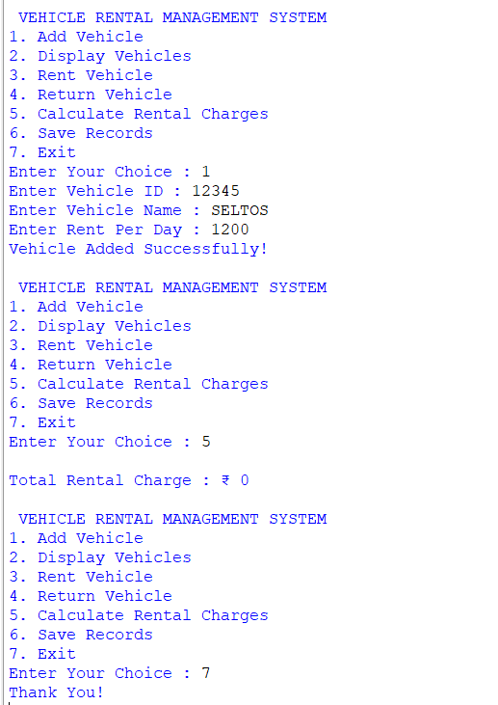
  - 7.CONCLUSION:
The Vehicle Rental Management System was successfully developed using Python and Object-Oriented Programming (OOP) concepts. The system enables users to add vehicles, rent and return vehicles, calculate rental charges, display vehicle information, and save rental records using file handling. This project demonstrates the implementation of abstraction, encapsulation, inheritance, polymorphism, exception handling, and file handling, making it a suitable mini project for learning OOP concepts in Python.

9. EXPENSE TRACKER SYSTEM:
  - 1.PROJECT TITLE:
Expense Tracker System Using Object-Oriented Programming in Python.
  - 2.AIM:
To develop an Expense Tracker System using Object-Oriented Programming (OOP) in Python that enables users to add expenses, display expense records, calculate total expenses, search expense details, and save expense records using file handling.
  - 3.DESCRIPTION:
The Expense Tracker System is a console-based Python application developed using Object-Oriented Programming concepts. It helps users maintain a record of their daily expenses in an organized manner. The system allows users to add new expense details, display all expense records, calculate the total amount spent, search for a particular expense using its ID, and save all expense records into a text file.The project demonstrates the implementation of OOP concepts such as Abstraction, Encapsulation, Inheritance, Polymorphism, File Handling, and Exception Handling.
  - 4.ALGORITHM:
- Start the program.
- Display the main menu.
- Add a new expense.
- Display all expense records.
- Calculate the total expenses.
- Search for an expense using Expense ID.
- Save expense records to a text file.
- Exit the program.
  - 5.SOURCE CODE:
from abc import ABC, abstractmethod
class ExpenseItem(ABC):

@abstractmethod
def display(self):
pass
class Expense(ExpenseItem):

def __init__(self, expense_id, category, amount):

self.__expense_id = expense_id
self.__category = category
self.__amount = amount

def get_expense_id(self):
return self.__expense_id

def get_category(self):
return self.__category

def get_amount(self):
return self.__amount

def display(self):

print("Expense ID :", self.__expense_id)
print("Category :", self.__category)
print("Amount :", self.__amount)
class ExpenseManagement(Expense):

expenses = []

def __init__(self):

self.total = 0

def add_expense(self):

try:

expense_id = input("Enter Expense ID : ")
category = input("Enter Expense Category : ")
amount = float(input("Enter Amount : "))

e = Expense(expense_id, category, amount)

ExpenseManagement.expenses.append(e)

print("Expense Added Successfully!")

except Exception:

print("Error While Adding Expense!")

def display_expenses(self):

if len(ExpenseManagement.expenses) == 0:

print("No Expense Records Available.")

else:

for e in ExpenseManagement.expenses:

print(" ")
e.display()

def calculate_total(self):

self.total = 0

if len(ExpenseManagement.expenses) == 0:

print("No Expense Records Available.")

else:

for e in ExpenseManagement.expenses:

self.total += e.get_amount()

print("\nTotal Expense : ₹", self.total)

def search_expense(self):

if len(ExpenseManagement.expenses) == 0:

print("No Expense Records Available.")

else:

expense_id = input("Enter Expense ID to Search : ")

found = False

for e in ExpenseManagement.expenses:

if e.get_expense_id() == expense_id:

print("\nExpense Found!")
e.display()

found = True
break

if not found:

print("Expense Record Not Found!")

def save_records(self):

file = open("expense_records.txt", "w")

for e in ExpenseManagement.expenses:

file.write(e.get_expense_id() + ",")
file.write(e.get_category() + ",")
file.write(str(e.get_amount()))
file.write("\n")

file.close()

print("Expense Records Saved Successfully!")

obj = ExpenseManagement()

while True:

print("\n EXPENSE TRACKER SYSTEM ")
print("1. Add Expense")
print("2. Display Expenses")
print("3. Calculate Total Expense")
print("4. Search Expense")
print("5. Save Records")
print("6. Exit")

try:

choice = int(input("Enter Your Choice : "))

if choice == 1:

obj.add_expense()

elif choice == 2:

obj.display_expenses()

elif choice == 3:

obj.calculate_total()

elif choice == 4:

obj.search_expense()

elif choice == 5:

obj.save_records()

elif choice == 6:

print("Thank You!")
break

else:

print("Invalid Choice!")

except ValueError:

print("Please Enter a Valid Number!")

  - 6.SCREENSHOT OF OUTPUT:
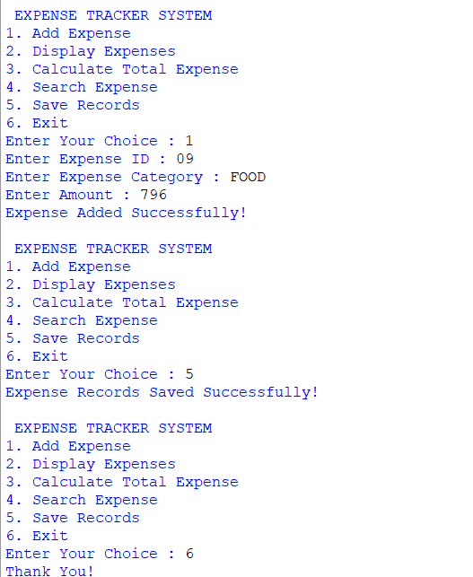
  - 7.CONCLUSION:
The Expense Tracker System was successfully developed using Python and Object-Oriented Programming (OOP) concepts. The system enables users to add expense records, display expenses, calculate the total amount spent, search expense details, and save expense records using file handling. This project demonstrates the implementation of abstraction, encapsulation, inheritance, polymorphism, exception handling, and file handling, making it a suitable mini project for learning OOP concepts in Python.

10.COURSE REGISTRATION SYSTEM:
  - 1.PROJECT TITLE:
Course Registration System Using Object-Oriented Programming in Python.
  - 2.AIM:
To develop a Course Registration System using Object-Oriented Programming (OOP) in Python that enables users to add students, register and drop courses, display registration details, and save course registration records using file handling.
  - 3.DESCRIPTION:
The Course Registration System is a console-based Python application developed using Object-Oriented Programming concepts. It helps educational institutions manage student course registrations efficiently. The system allows users to add student details, register students for courses, drop registered courses, display all registration records, and save the records into a text file.
The project demonstrates the implementation of OOP concepts such as Abstraction, Encapsulation, Inheritance, Polymorphism, File Handling, and Exception Handling.
  - 4.ALGORITHM:
1.Start the program.
2.Display the main menu.
3.Add a new student.
4.Display all student registrations.
5.Register a course for a student.
6.Drop a registered course.
7.Save registration records to a text file.
8.Exit the program.
  - 5.SOURCE CODE:
from abc import ABC, abstractmethod
class RegistrationItem(ABC):

@abstractmethod
def display(self):
pass
class Student(RegistrationItem):

def __init__(self, student_id, student_name, course):

self.__student_id = student_id
self.__student_name = student_name
self.__course = course

def get_student_id(self):
return self.__student_id

def get_student_name(self):
return self.__student_name

def get_course(self):
return self.__course

def set_course(self, course):
self.__course = course

def display(self):

print("Student ID :", self.__student_id)
print("Student Name :", self.__student_name)
print("Course :", self.__course)
class CourseRegistration(Student):

students = []

def __init__(self):

pass

def add_student(self):

try:

student_id = input("Enter Student ID : ")
student_name = input("Enter Student Name : ")
course = input("Enter Course Name : ")

s = Student(student_id, student_name, course)

CourseRegistration.students.append(s)

print("Student Added Successfully!")

except Exception:

print("Error While Adding Student!")

def display_registrations(self):

if len(CourseRegistration.students) == 0:

print("No Student Records Available.")

else:

for s in CourseRegistration.students:

print(" ")
s.display()

def register_course(self):

if len(CourseRegistration.students) == 0:

print("No Student Records Available.")

else:

student_id = input("Enter Student ID : ")

found = False

for s in CourseRegistration.students:

if s.get_student_id() == student_id:

course = input("Enter New Course Name : ")

s.set_course(course)

print("Course Registered Successfully!")

found = True
break

if not found:

print("Student Record Not Found!")

def drop_course(self):

if len(CourseRegistration.students) == 0:

print("No Student Records Available.")

else:

student_id = input("Enter Student ID : ")

found = False

for s in CourseRegistration.students:

if s.get_student_id() == student_id:

s.set_course("No Course Registered")

print("Course Dropped Successfully!")

found = True
break

if not found:

print("Student Record Not Found!")

def save_records(self):

file = open("course_records.txt", "w")

for s in CourseRegistration.students:

file.write(s.get_student_id() + ",")
file.write(s.get_student_name() + ",")
file.write(s.get_course())
file.write("\n")

file.close()

print("Course Registration Records Saved Successfully!")

obj = CourseRegistration()

while True:

print("\n COURSE REGISTRATION SYSTEM ")
print("1. Add Student")
print("2. Display Registrations")
print("3. Register Course")
print("4. Drop Course")
print("5. Save Records")
print("6. Exit")

try:

choice = int(input("Enter Your Choice : "))

if choice == 1:

obj.add_student()

elif choice == 2:

obj.display_registrations()

elif choice == 3:

obj.register_course()

elif choice == 4:

obj.drop_course()

elif choice == 5:

obj.save_records()

elif choice == 6:

print("Thank You!")
break

else:

print("Invalid Choice!")

except ValueError:

print("Please Enter a Valid Number!")
  - 6.SCREENSHOT OF OUTPUT:
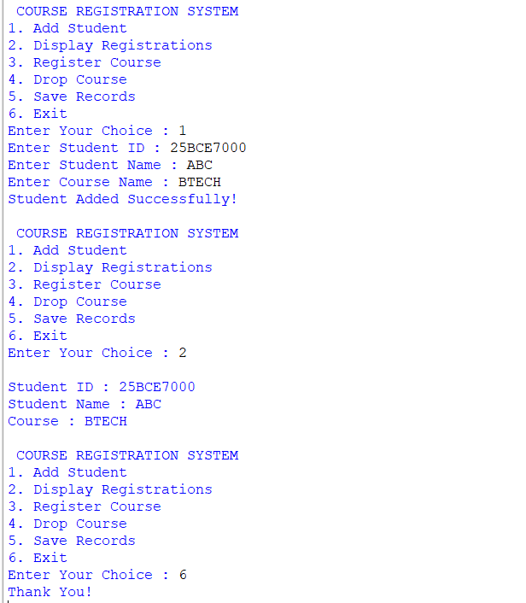
  - 7.CONCLUSION:
The Course Registration System was successfully developed using Python and Object-Oriented Programming (OOP) concepts. The system enables users to add students, register and drop courses, display registration details, and save records using file handling. This project demonstrates the implementation of abstraction, encapsulation, inheritance, polymorphism, exception handling, and file handling, making it an effective mini project for learning OOP concepts in Python.

